User Guide for SearchFlickr

<Search and download public photos on Flickr>

*Files:*

/downloads

/static:

/Style Sheet.css

/templates:

/index.html

/results.html

/code.py

1. Make sure the following programs are installed:
   * Python: <https://www.python.org/downloads/>
     + Make sure the “python” command is available on command line. If not, add your version of Python’s installation directory (usually C:/Python27 if you downloaded Python 2.7) to the PATH as shown in this video: <http://www.youtube.com/watch?v=vj7oFMrf8wM>
   * Webpy: <http://webpy.org/install#install>
     + Download <http://webpy.org/static/web.py-0.37.tar.gz> and extract it.
     + Go to the web.py directory and run python setup.py install on command line.
   * Flickr API kit: <https://pypi.python.org/pypi/flickrapi>
     + Download the zip file and extract it.
     + Go to the flickrapi directory and run python setup.py install on command line.
2. Go to the SearchFlickr directory and run the code.py file on command line.

* python code.py

The following line will appear upon success of hosting the server.

* http://0.0.0.0:8080/

1. Open the <http://localhost:8080/> page on a browser.
2. Follow the instructions to fill in the form for search criteria of photos and submit. Any combination is allowed.

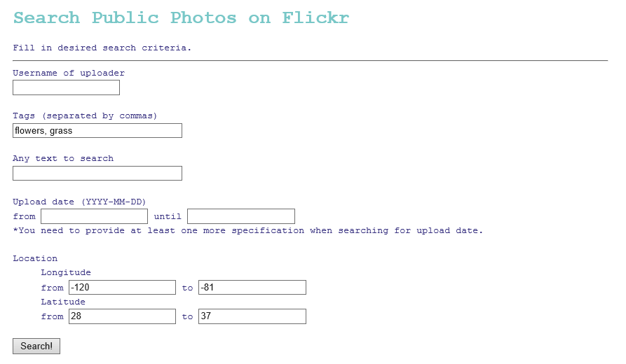

1. Your search result (first 20 photos) will appear.

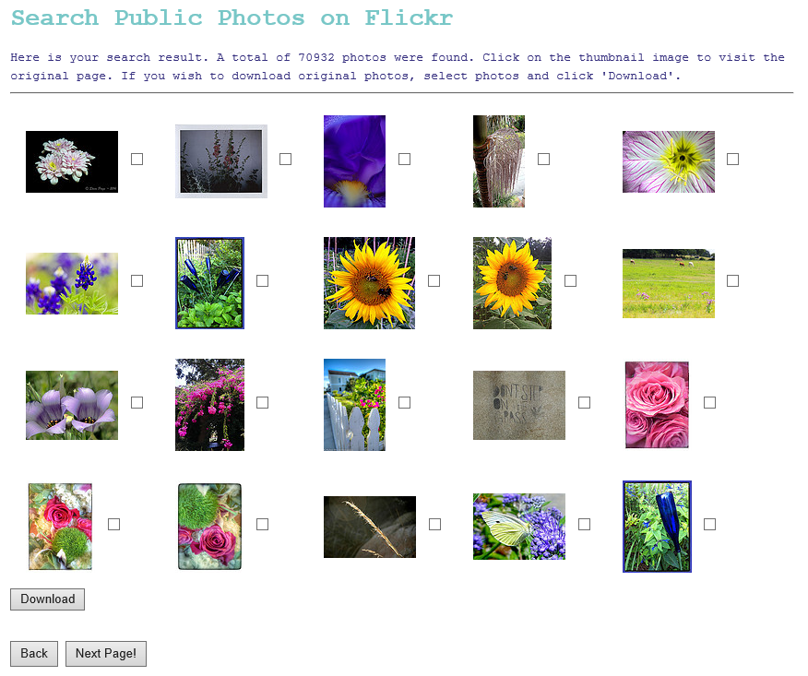

* If you click the thumbnail of a photo, you will be directed to the original Flickr page.

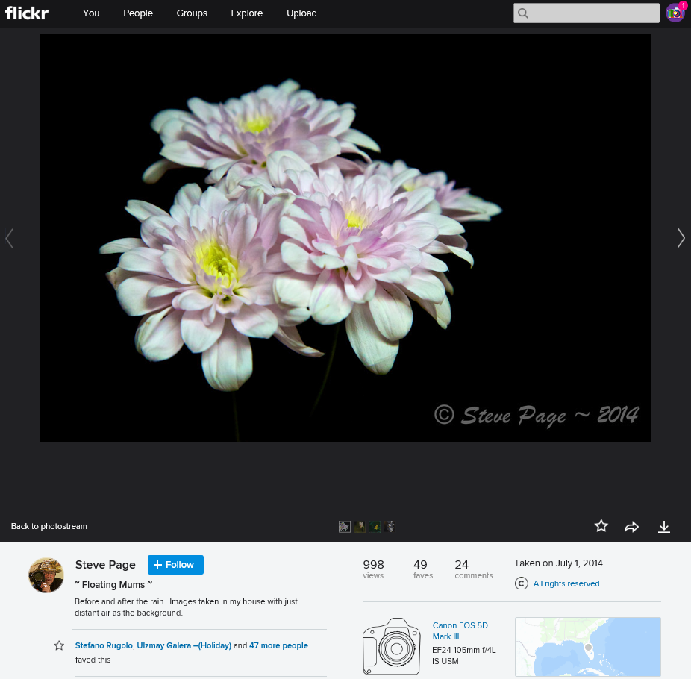

* Select photos that you wish to download from your search result and click “Download.”

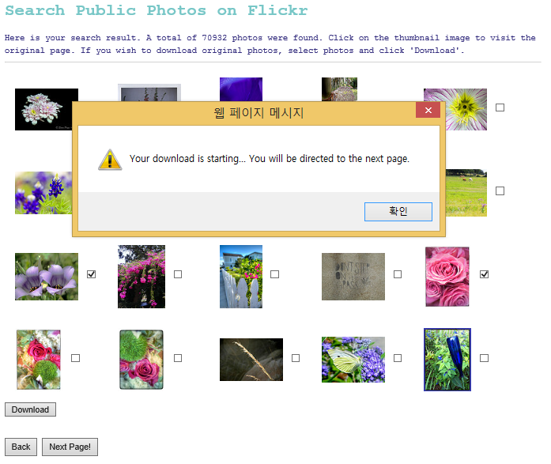

* + The message shown above will appear and your download will start. Once your download finishes, the message shown below will appear on your command line (shell).

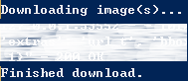

* + Go to the “downloads” directory and check the downloaded photos.

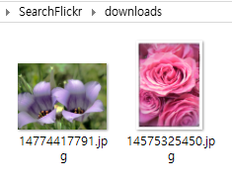

* + Meanwhile, you will be directed to the next page of 20 photos for your search.

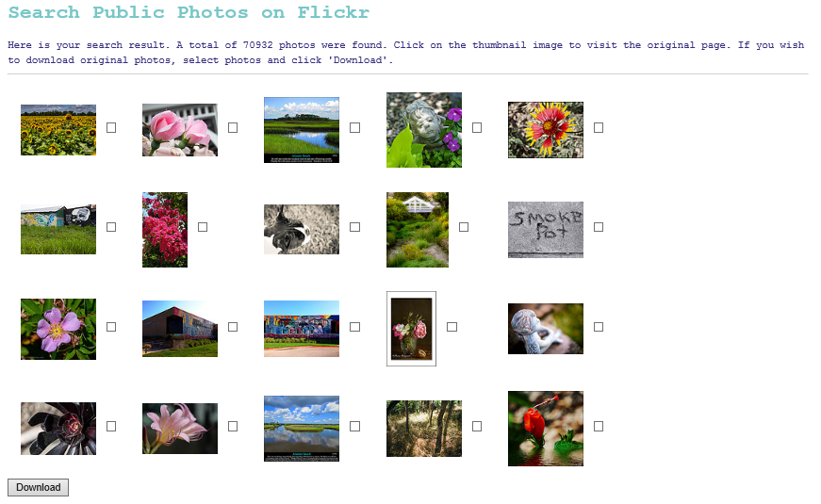

* Click “Next Page” to view the next 20 photos of your search without downloading any of the current photos.
* At any point of your search, click “Back” to go to the previous page, and the page title “Search Public Photos on Flickr” to go to the home page.

1. Once you are finished, quit the server by pressing ctrl + c on command line.